Test Case ID | Software Feature | Steps | Expected | Actual Result | Passed/Failed
01 | User login successful. | 1. Run the program.  2. Enter: admin as username.  3. Enter: 123 as password. | The Hospital Management System opens successfully, and it asks for a username.  When the username is given the program will asks us to provide a password.  After we enter correct login details it shows login successful and user menu will be displayed.  If we enter wrong credentials, it shows error and the program will ask us to re-run the program. | 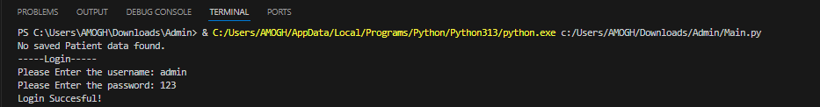  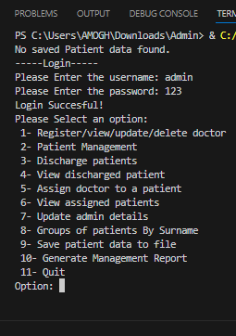 | passed

Test Case ID | Software Feature | Steps | Expected | Actual Result | Passed/Failed
02 | Option 1 selection and its working.  Register/view/  update/delete doctor | 1. Run the program.  2. Enter: admin as username.  3. Enter: 123 as password.  4. Select option 1  Displayed as  Register/view/Update  / Delete doctor | The Doctor Management opens successfully, and it asks us to choose the operation.  There are 4 operations to choose those are: -  1. Register Doctor  2. View Doctor  3. Update Doctor  4. Delete Doctor  After choosing anyone of the following operation it continues to perform selected operations. | 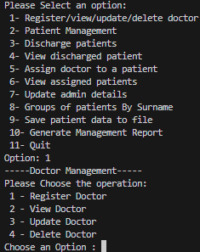  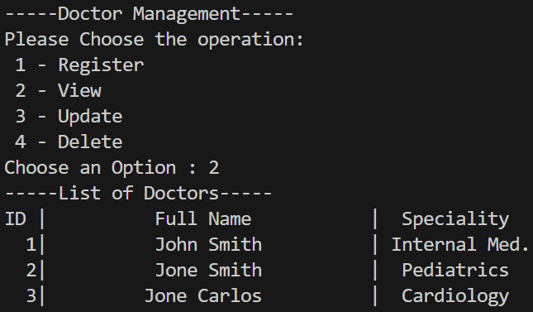 | passed

Test Case ID | Software Feature | Steps | Expected | Actual Result | Passed/Failed
03 | Option 2 selection and its working.  Patient Management | 1. Run the program.  2. Enter: admin as username.  3. Enter: 123 as password.  4. Select option 2  Displayed as  Patient Management | The Patient Management opens and it will ask us to choose 3 operations: -  1. Add Patient  2. View Patient  3. Update Patient  If we choose anyone operation it will be performed.  For example, if we choose operation (2) i.e. View patient it shows all the registered patients. | 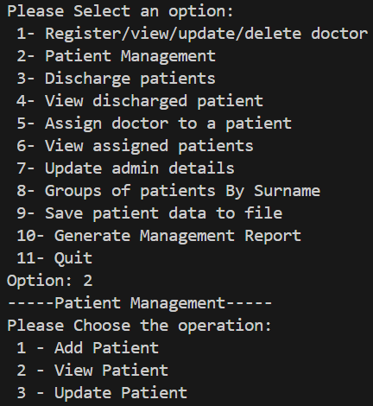  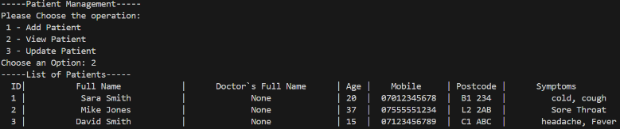 | passed
Test Case ID | Software Feature | Steps | Expected | Actual Result | Passed/Failed
04 | Option 7  Update admin details | 1. Run the program.  2. Enter: admin as username.  3. Enter: 123 as password.  4. Select option 7  Displayed as  Update admin details  5. Choose the field to be updated like username, password and address. | The Update admin panel will open and it will ask us to choose 3 operations: -  1. Update admin username.  2. Update admin password.  3. Update admin address.  If we select an operation, it will be performed. We can update username, password and address. And updated data will be stored as .Json file | 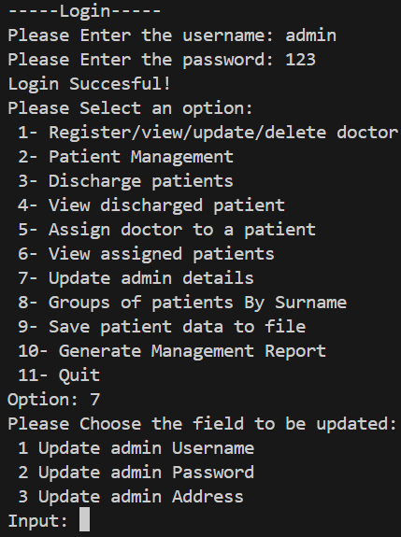  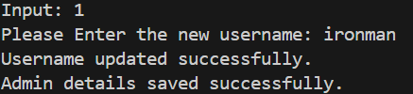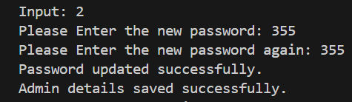  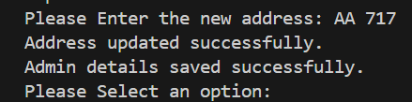 | passed
Test Case ID | Software Feature | Steps | Expected | Actual Result | Passed/Failed
05 | Option 3  Discharge patients. | 1. Enter: admin as username.  2. Enter: 123 as password.  3. Select option 3  Displayed as  Discharge patients  4. Do you want to discharge a patient window will appear give yes.  5. Enter patient ID to discharge. | When we select option 3 displayed as Discharge patients.  System will ask Do you want to discharge a patient? If yes patient will be discharged and if no system will run back to give options.  After Yes system will ask to Enter the patient ID to discharge. When valid patient ID is entered the patient is discharged.  If invalid patient ID entered it will show ID does not exit. | 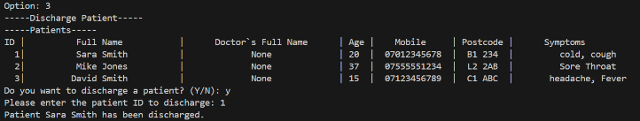  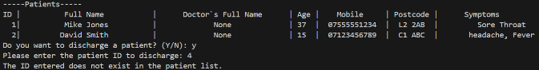  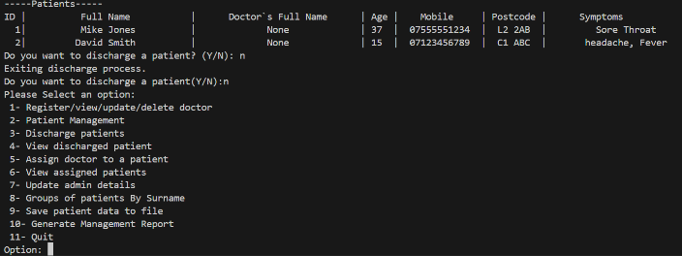 | passed
Test Case ID | Software Feature | Steps | Expected | Actual Result | Passed/Failed
06 | Option 4  View discharged patient. | 1. Run the program.  2. Enter: admin as username.  3. Enter: 123 as password.  4. Select option 3  Displayed as  View discharged patient  5. The list of discharged patients will be displayed. | When we select option 4 displayed as view discharged patients the function will run and there are two possibilities: -  1. If there are any patients discharged recently it will show the list of discharged patients.  2. If there are no patients discharged recently it will show No patients have been discharged yet. | 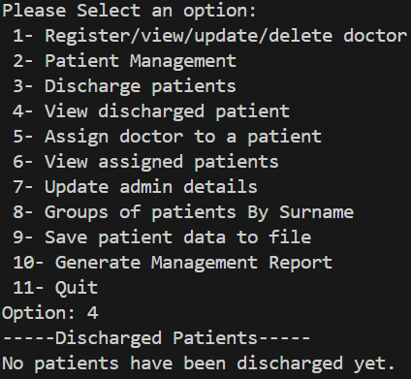 | passed
Test Case ID | Software Feature | Steps | Expected | Actual Result | Passed/Failed
07 | Option 5  Assign Doctor to a patient. | 1. Run the program.  2. Enter: admin as username.  3. Enter: 123 as password.  4. Select option 5  Displayed as  Assign Doctor to a patient.  5. Please enter the patients ID.  6. Please select the doctor that fits treating patient symptoms.  7. Please enter the doctor ID.  8. The patient is now assigned to the doctor. | When we select option 5 displayed as Assign Doctor to a patient.  A list of patients stored in database will be displayed.  Then system will ask us to enter the patient ID, and there are 2 possibilities: -  1. If valid ID is selected it will go to the next step.  2. If invalid ID is selected it will show the ID entered was not found.  After valid ID is selected the program will ask us to select the doctor that fits the patient symptoms and also it will ask us to enter the doctor ID to assign doctor to a patient.  If valid ID entered it will show the patient is now assigned to a doctor.  If invalid ID is entered it will show the ID entered was not found. | 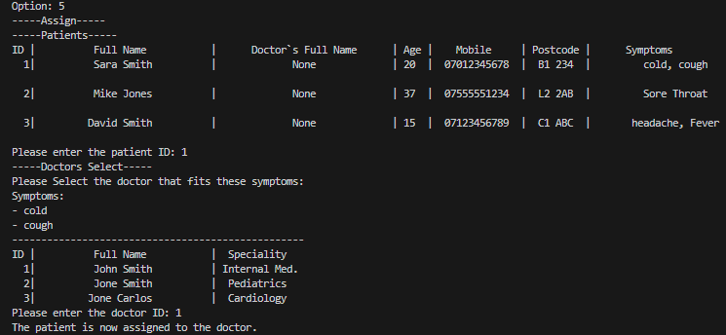  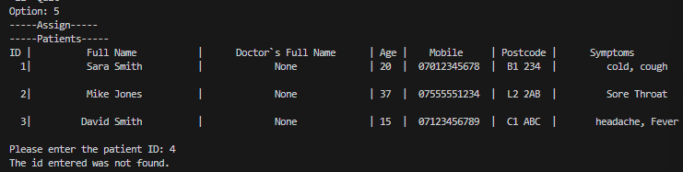  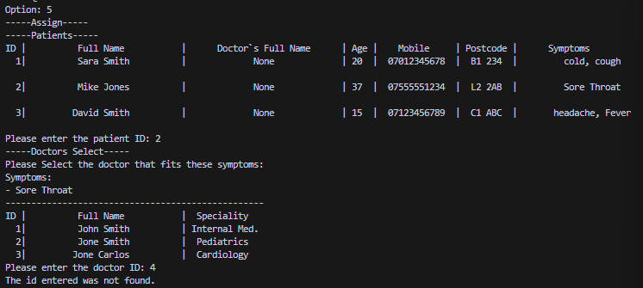 | passed

Test Case ID | Software Feature | Steps | Expected | Actual Result | Passed/Failed
08 | Option 6  View assigned patients | 1. Run the program.  2. Enter: admin as username.  3. Enter: 123 as password.  4. Select option 6  Displayed as  View assigned patients.  5. Please enter the ID of the doctor to view their patients. | When we select option 6 displayed as View assigned patients.  A list of doctors stored in the data base will be displayed.  Program will ask us to Enter the ID of the doctor to view their assigned patients.  If valid doctor ID is entered it will show list of assigned patients to the doctor.  If invalid doctor ID is entered it will show the ID entered was not found.  If no patients are assigned to the doctor the program will show the particular doctor selected currently has no assigned patients. | 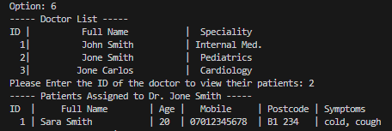  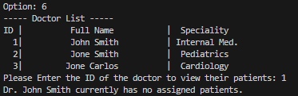  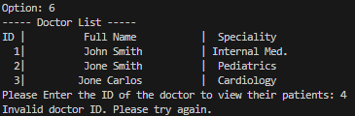 | passed

 | Test Case ID | Software Feature | Steps | Expected | Actual Result | Passed/Failed
 | 09 | Option 8  Groups of patients By Surname | 1. Run the program.  2. Enter: admin as username.  3. Enter: 123 as password.  4. Select option 8  Displayed as  Groups of patients By Surname  5. The list of patients grouped by family will be displayed. | When we select option 8 displayed as Groups of patients By Surname.  The program will display the list of patients grouped by family.  The program groups all the patients together whose surname are same. | 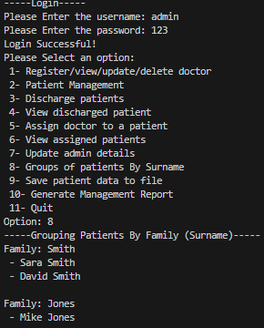 | passed
Test Case ID |  | Software Feature | Steps | Expected | Actual Result | Passed/Failed
10 |  | Option 10  Generate Management Report | 1. Run the program.  2. Enter: admin as username.  3. Enter: 123 as password.  4. Select option 10  Displayed as  Generate Management Report  5. The management report will be generated as PDF | When we select option 10 displayed as Generate Management Report.  The program will show generating management report.  After 2 seconds the program will show Management report generated successfully and saved as management_report.pdf  HOSPITAL MANAGEMENT REPORT will be generated as PDF and it will be saved in the folder automatically. | 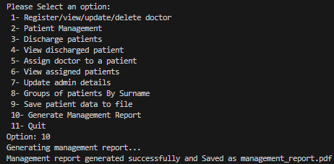  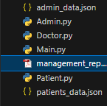  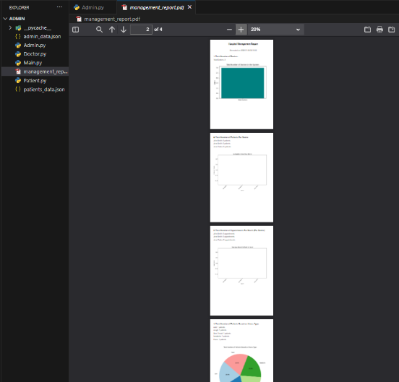 | passed

